Intro:

Moai 200 takes Gcode as input for printing. Many steps are similar to FDM printing. However, there are considerations unique to SLA printing and ecosystem. This instruction covers how to print on Moai 200 and how you can build a printing process that suits your need.

While Moai 200 is a SLA printer, it uses standard Gcode as toolpath for its laser the same way FDM printer extruder moves based on Gcode and print layer by layer. Many ideas and considerations are the same. But there are significant difference as well

Same:
- A good first layer. This is as important as FDM. Moai 200 is a bottom up SLA printer, meaning it prints the object upside down. A good adhesion means the object would not break off during the printing or fall down into vat:
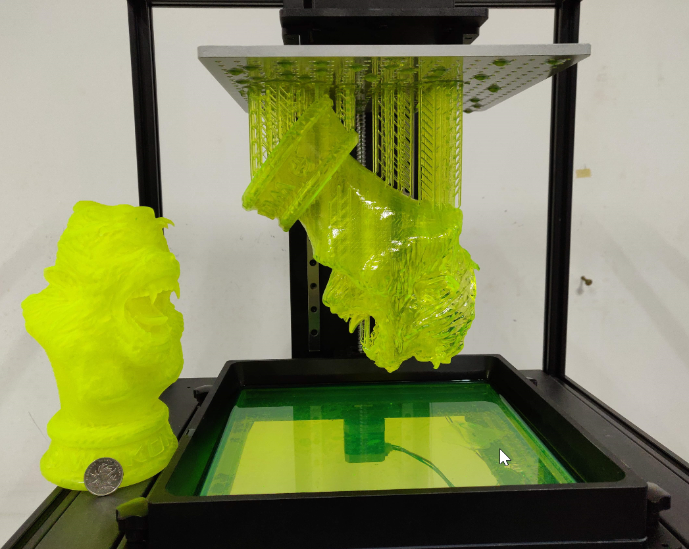
There are couple ways you can get a strong first layer with longer exposure time, stronger laser power and use of brim. You can also help the object to stay on platform by reducing object weight via hollowing. More on these points later.

- Support generation.
While Moai 200 prints upside-down, it still has to deal with gravity and support is as important as ever. The shape and size of support are different but the idea is the same.
- Speed vs detail.
Like most SLA, Moai 200 typically prints with a layer of 0.025mm to 0.1mm. The more detail, the longer it takes to print. 0.1mm is commonly used for prototyping while 0.05mm is most frequently used. 0.025mm are used for professional results. Anything lower than that can still be done but now the resin’s own error tolerance comes into play. Any desktop level printer talking about printing less than 0.015mm (15 microns) are not be realistic about the materials they used. For Moai 200 printing, we recommend 50 microns and 100 microns for detail, and speed

Difference

- Upside down printing
Because Moai 200 is a bottom up printer like Form1+ and Form2, you have to consider gravity that may pull down the object. This is only a concern when printing large object. The hollowing section deals with this. This also affects how prints are oriented and how you deal with overhang. In general, Moai 200 can deal with overhang very close to 0 degree.

- Resin
Resin is significantly different than filament in many ways. Resin needs post-processing to fully cure it. Resin can also irritate skins so please see the safety section down below. And finally, because the object is immersed in the resin, if the object is hollow, there may be resin trapped inside. When you hollow an object, you should also consider drain holes. These are covered below

Safety

There are two potential safety hazards with laser SLA printers:
- Laser
- Resin
- Post Processing

Laser
Moai 200 uses a 405nm 150mw UV laser. It is considered low powered laser but still can hurt human eyes if aimed directly at the focus length. Therefore, please wear goggle if you are going to be testing it with panels removed. Moai’s panels can block the harmful UV light so you will be ok if it is completely closed. Reflect UV lights are much weaker but still avoid looking at it over extended time.

Resin
Moai 200 Resin, as well as almost all SLA printer resins can irritate skins if it comes in direct contact with the skin. Wear gloves when handling resins and holding not-fully cured objects. Wash with warm water and soap if resin comes in contact with your skin. If your eyes come in contact with resin, quickly wash with warm water only to remove as much as you can and seek professional help immediately. Resin safety has its own safety document in the folder

Post-Processing
High content 90%+ ethanol is recommended for Moai 200 resin. IPA can be used as a substitute. Please wear glove when handling it to avoid directly exposure to skins and eyes or it may cause over-dryness. Please keep it away from flame.

Formlabs has a nice safety instruction that applies to Moai:
https://formlabs.com/support/printers/form-1/safety-first/

Before we gets into the detail, please know that
DO NOT REMOVE RESIN VAT WITHOUT TAKING DOWN THE BUILD PLATFORM.
Forget doing that may result resin on the build platform drip into the system below, causing significant damage to galvo and short the boards.

Print Steps:
This is a set of the common steps in sequence when printing on a SLA printer like Moai. Not all steps are necessary and you may skip 1 and 2 depending on the object. This guide is designed for using Asura to prepare for prints.

This is generally the workflow for preparing a file for printing on Moai

- Positioning and Orientation of the object.
- Does object need hollow?
- Does the object need support and base?
- Output file for printing (slicing)

- What is the best position and orientation for the print?
This should be considered with base and support as well. The optimal orientation for an object is to have a high print success rate with least support. This means avoiding having difficult to print sections like islands (parts of the object that have negative angles) or long horizontal feature. At the same, consider having enough surface area to the plate so it can stick well. Let’s use this Peopoly Moai 200 model file as a case study. The file can be found here.

When you use load command  to open the file, you will find the Moai 200 is sitting in the center of the platform. For most of the models, this may be fine.
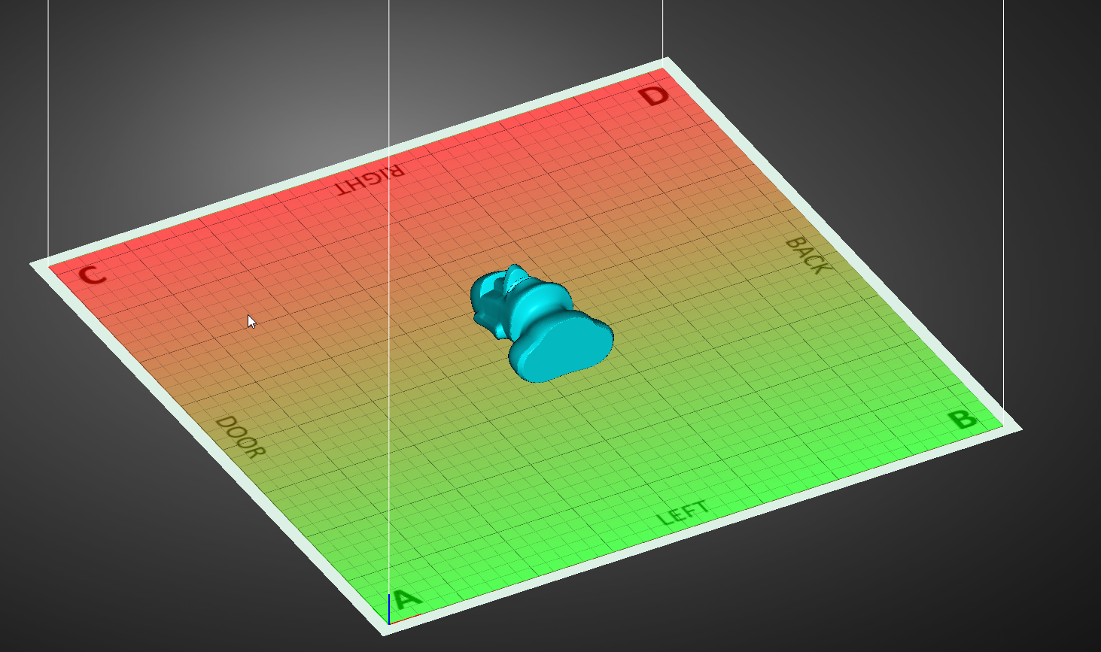

Here you can see the platform labels out where the model is located in the Moai 200 printer if it is printed as it is. Door is the front door, Left is the left side of the printer and vice versa. As some of you may notice, Left and Right are opposite of what you would expect, and that is why we had to label them.

To move and turn the model, let’s use move / rotate command 
You will see the circles of allowing to move and turn the selected model
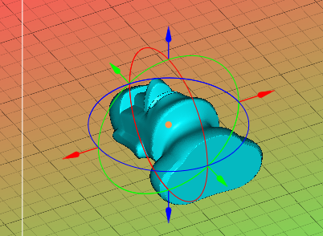
By clicking and dragging on of the circle, you can turn the model and here is an example.
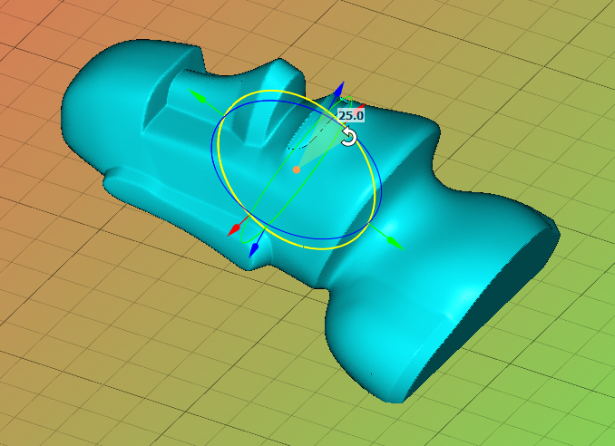
The number 25 signifies the degree of turning.

Let;’s turn the model by 75 degree, dragging on the red circle
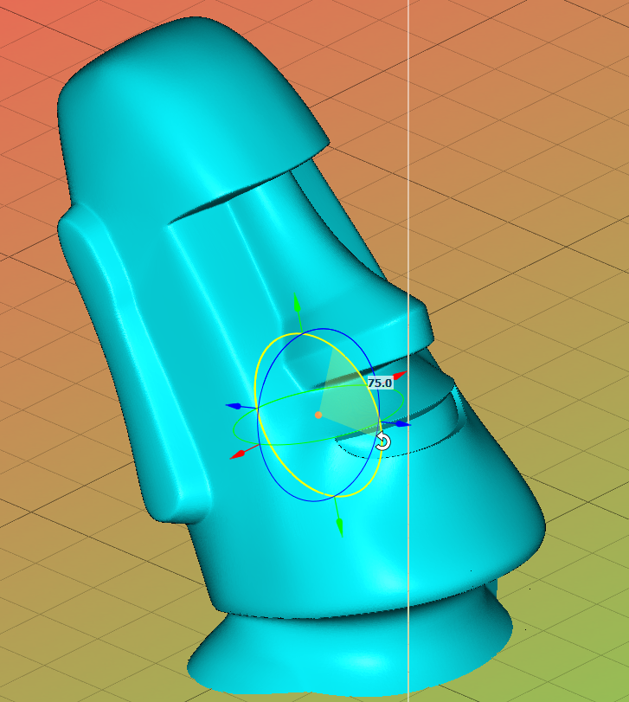
Click to the platform and you will have
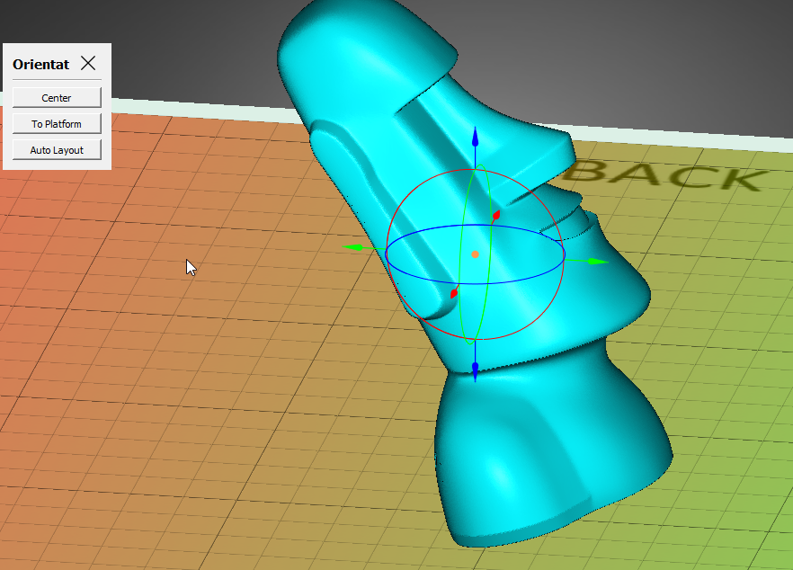

We select this angle to show minimize the maximum surface area of the layers so that it has the highest print success rate with the least amount of the support.

2. Hollowing
One of the key factors when printing on “Bottom-Up” SLA printer that does not exist on FDM is the weight of the object and the cost of resin. Thus hollow out a model is an important tool for user as it can save a lot of time and resins.

The decision is as such:
Can the object to be too big and too heavy such that it may fall out of the platform and into the vat?
Is transparent resin used? Because it may show the internal support if the object is hollowed out
Save some resin?

How to decide:
If you are printing a solid object with a large internal volume, then it may be best to consider hollowing out.

This is the hollow function  in Asura

After clicking it, the model is hollowed out and shown in different colors
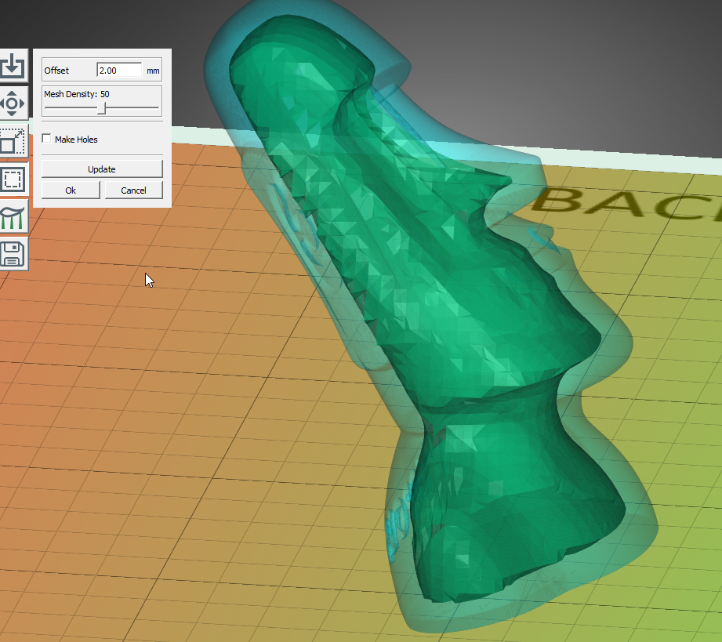
The lighter bluish green is the solid part while the deeper green within the object is the hollowed out portion.

The offset here means the thickness of the shell. 2mm is a good starting point and you could make it thinner to save resin and time. However, under 1mm is not recommended and the results have a lot to do with the type of resins you are using. Resins with high hardness can print thinner wall while softer may not be able to print thin wall as well.
The mesh density is how accurate the internal hollowed part is and for most of you, just leave it at 50 is fine.

When you hollow a model, you almost always create holes so that resins trapped inside can be drained. And you would need at least 2 holes for drainage to work properly

By clicking Make Holes, you can get additional functions
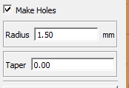

Here the cursor becomes a guide for drilling holes based on the paramters. We recommend radius to be 1.5mm if you are not sure how to start.
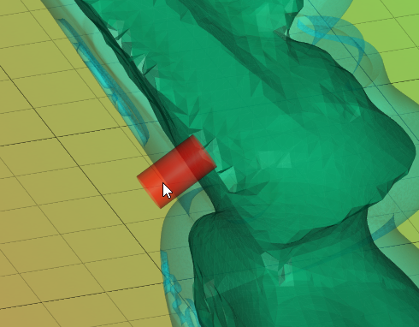

Here you can left click to pick the spot to tap holes and right click to remove spots that are tagged for new holes.
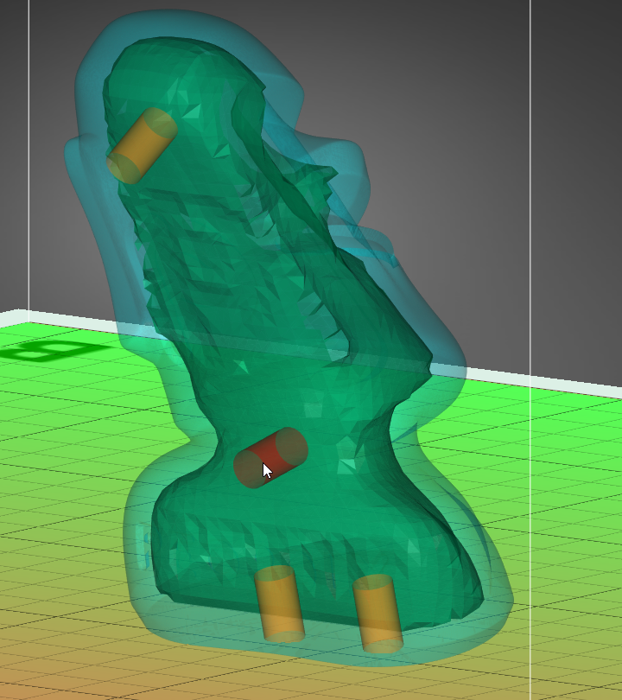
Click Ok and you have a hollowed and tapped model

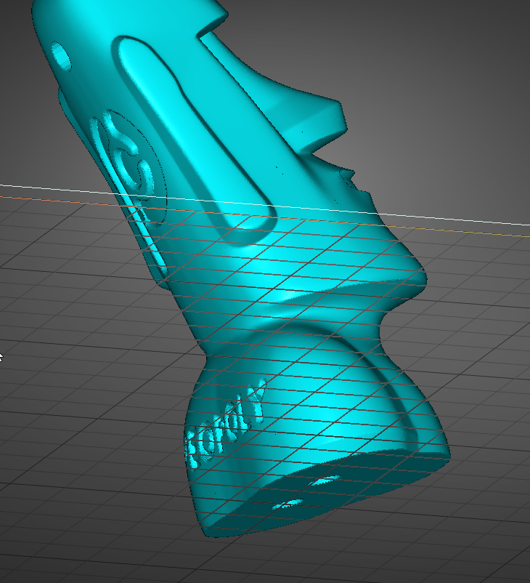
-
3. Support generation (v3 Asura)

Support generation is a key part of the printing process. SLA and FDM printers are so different, they require a different type of supports for overhangs. Asura is specifically designed for resin printing and has very user friendly features.

Before we proceed, make sure your support parameters are set as below. You can click on the small triangle on the right of the parameter to open up settings
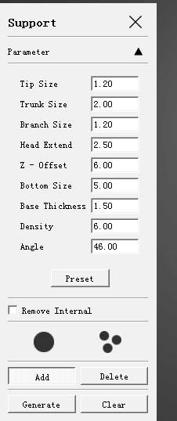

Make sure the individual base is selected


For most of the users, simply click  and select generate and you are ready to move to next step. Or if you want it quickly, right click on the model and select Auto Support. This creates a full base, raise the model up to 5mm clearing from the build plate and add support.
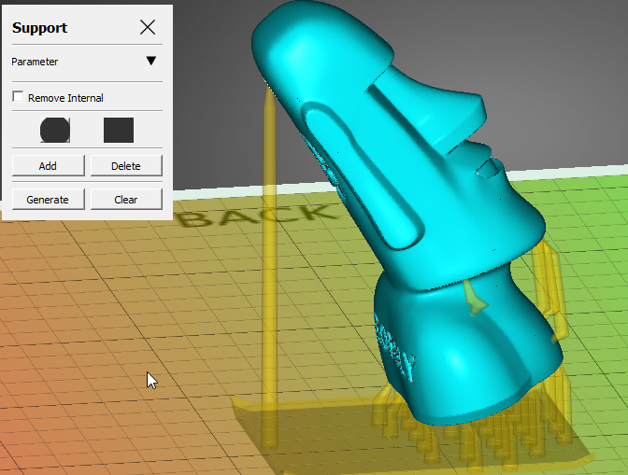

If you don’t like what you see, you can also click on add / delete to manual edit supports.
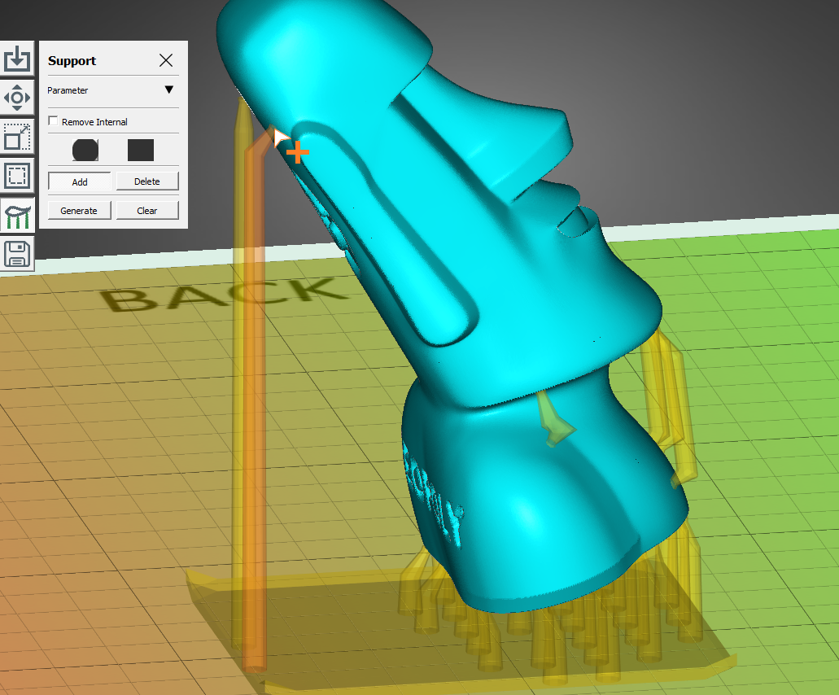

You can learn about support’s parameters in Asura user guide.

-

-
Slicing (V3 Asura)

Asura uses Cura software engine to convert model to a format that Moai 200 can print. We have simplified the process in Asura such that all you need to do is

- Select Export 
- Pick a layer height. 100um is very popular and useful for most applications
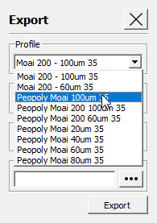
- Click to give the file a name (make sure it is no longer than 25 characters)
- And click 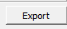 to save the gcode

Save the gcode to SD card. Ignore the print time as laser moves much faster than extruder. It is often one sixth or even less time.

And make sure place the gcode in the gcode directory of the SD card (X:\gcode\)
File name should have less than 25 characters

And you are ready to print
-
The positioning of the print
Below is how print positions on Cura compares to its location when printed in Moai:
A->A and vice versa.
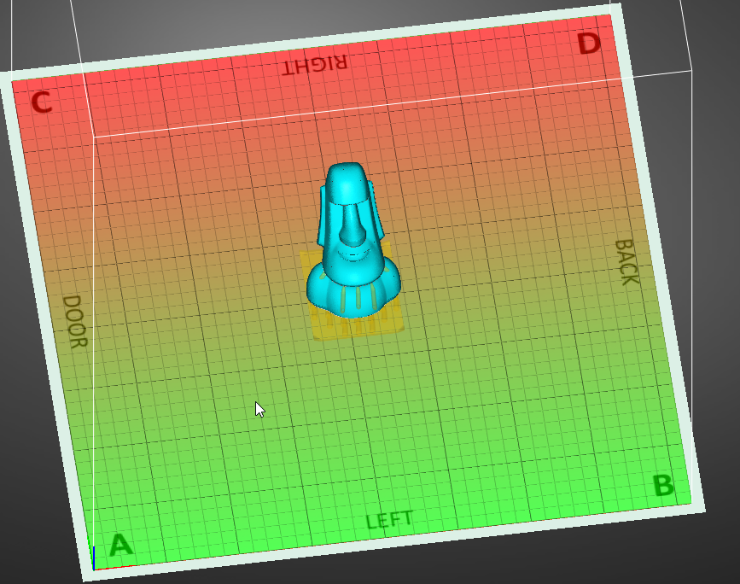
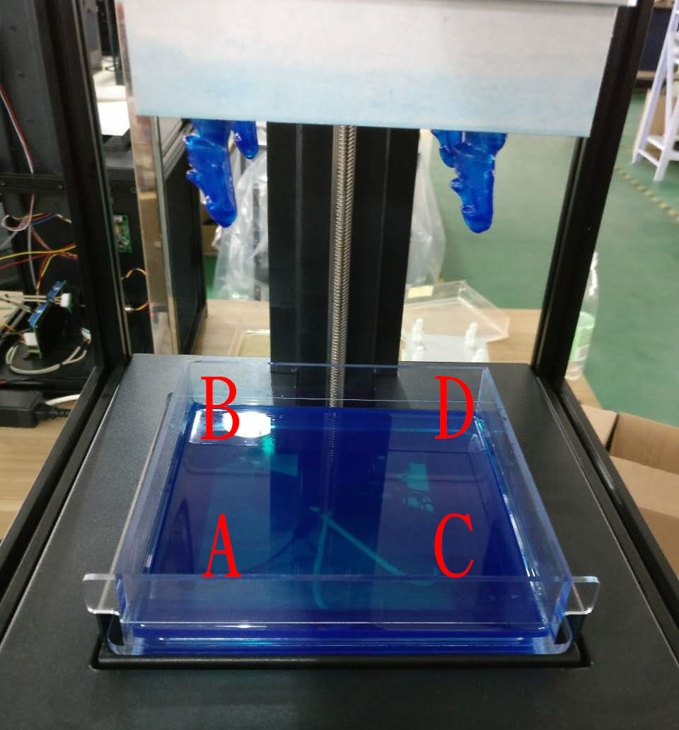

-
Extra notes on Gcode:

You could use other slicers but some of the display feature may not show correctly and has unneeded starting gcode.
Basically, Moai 200 interpret only a few gcode command:
G0 G1 for movement. F for speed and E for exposure
Home command works as well. Because there is no filament, there is no need to extrude a little bit before printing, please remove that code if you are using your own slicer

Notes on Exposure

a bit about laser power, exposure and resin as you guys starting to print and experiment:

1. the more transparent and lighter the color, the less energy they absorb, thus needed higher exposure. keeping laser light constant black/blue can go up to 100 while clear may be around 75mm with laser power holding constant

2. higher exposure can be achieved by higher laser power and/or slower laser speed

3. the photosensitive chemical reaction does not correlate linearly with exposure amount. this means you cannot cut the laser energy by simply half and cut the speed down by half and expect the same results. once laser power drops to a certain level, it will not cure fast enough to have a good success rate

4 The best approach I found so far is to find the minimal laser energy that will solidify with a print speed of 80mm/s for layer height at 0.1mm. and then fine tune by increase / decrease speed. the lower laser power you can get away to do successful print, the better surface finish as laser spot would be smaller

Post processing

This is the least fun part of any kind of 3D printing but a necessary step. When Moai 200 or any SLA printer finishes a print, the resin is cured enough to create a solid shape. However, it is still soft and not completely cured to achieve its final physical look and mechanical property. More is needed.

3 key stages of post-processing:

- Removal of the print
Please use metal scraper to chip the print off the built platform. This will feel like printing off FDM. First you have to loose the bolt on top of the build platform. When you remove the platform, please turn it over the platform surface face up quickly so the resin doesn’t drip to your hand or to get on the printer. Because prints are still not fully cured, please be careful not to chip the object with sharp item or it will leave marks. You can first scrape off resin on the platform (not on the object) back to the vat before removing the object. This helps recycle some resins

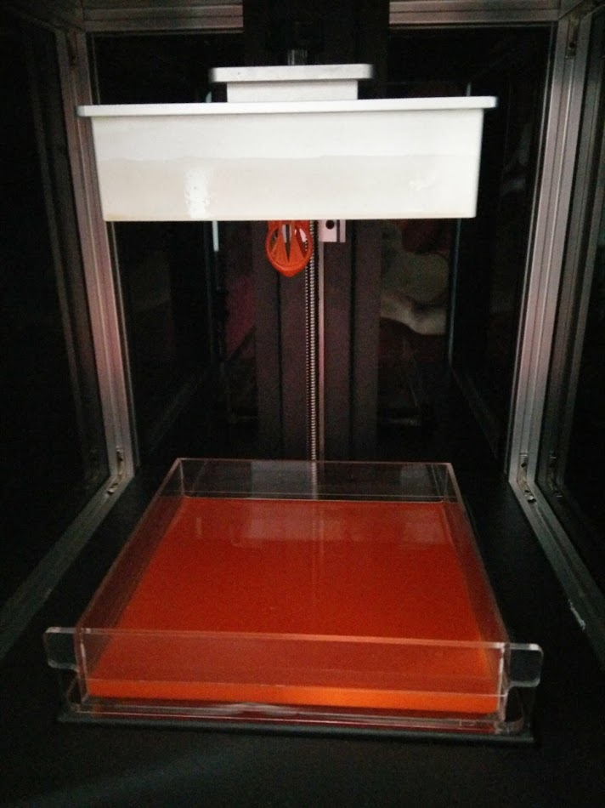

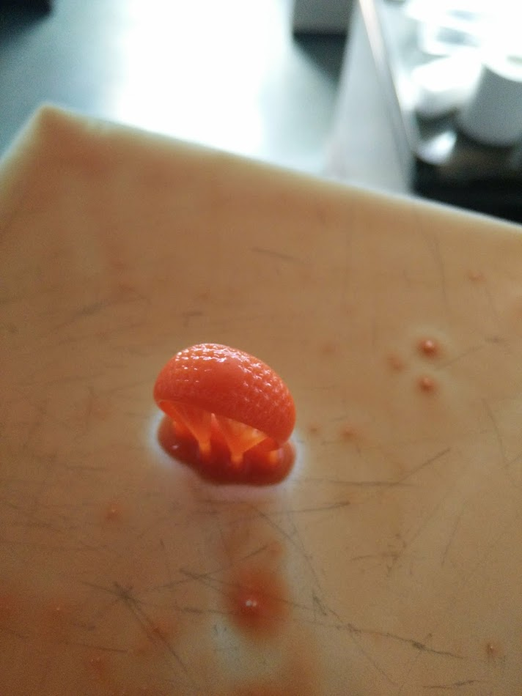

- Washing off
Not only object is not fully cured, there are resins sticking on the object. We must first removed those resins by use ethanol.
Have 2 containers, one filled with ethanol (not 100% filled, 30%-50% depending on the depth). And one filled with water. Dip the object in ethanol first and quickly shake for 30 seconds before put the object into the water and shake for 10 seconds. Repeat this at least twice. More if there are still resin on the object. There is no need to submerge object in the ehanol for extended time (>2 minutes).

- Final Curing
Please the object under direct sunlight or under UV light fixture. Sunlight is slower but free, and can be speed up by submerge the object in water. UV light is quicker but need special equipment.

Formlabs has a nice guide that applies to Moai:
https://formlabs.com/support/finishing/post-print-steps/

After curing, you could use UV blocker like this: http://www.krylon.com/products/uvresistant-clear-coating/
To prevent further over-curing that may lead to brittleness.

Cleaning

This is definitely the least fun part of the process. You do not need to clean the vat or the system all the time but you may need to, especially after a failed print.

To prevent failed prints (and sometimes successful prints) leaving small half-cured objects in vat that could affect future prints, it is best to inspect when there is a failed print. You can inspect by holding the vat up under artificial lights (not UV light).

DO NOT REMOVE VAT BEFORE REMOVING THe PLATFORM

To remove free floating tiny objects in the vat, you can use a flat head tweezer. If there is too many tiny objects in the vat, you could filter out them using a coffee filter

Here is another good write up from Formlabs that apply to laser SLA printer:
https://formlabs.com/support/printers/form-2/keeping-resin-tank-clean/

